The 4th "Dadohae Cup" International Regatta 2016

◌ Period: September 28, 2016 (Wed) ~ October 2, 2016 (Sun)
◌ Location: Waters of Mokpo-Cheongsando Island-Chodo Island-Cheongsando Island
◌ Hosts: Jeollanamdo. Mokpo-si. Wando-gun
◌ Superintendent:“Dadohae Cup” International Regatta Organization Committee,
Mokpo-si Sailing Federation,
Sehan University SRL Marine Leisure Specialized Project Group
◌ Sponsors: Ministry of Culture, Sports & Tourism (Korea Sports Promotion Foundation),
Sehan University

Notices of Regatta

1. Rules

1.1 This race applies the rules defined in the ISAF 2013~2016 Sailing Race Rules, ORC Rules (ORC Class), KSAF PHRF Rules (OPEN Class), Notices of Regatta and Sailing Instructions, and Category 4 as defined in ISAF Offshore Special Regulations 2016~2017 is also applicable to this race.
1.2 The national federation regulations are not applied.
1.3 When there is any conflict or contradiction between the Notice of Regatta and the Sailing Instructions, the Sailing Instructions have precedence over the Notices of Regatta.
1.4 In the case of any conflict or contradiction with regard to languages used, English has precedence over other languages.

2. Advertisement

2.1 The advertisement regulation of ISAF is applied. There is no restriction regarding the display of advertisements by the participants and their yachts, and the advertisement for Regatta by the organizing committee accords with following.
1) The bow number that includes the advertisement must be indicated on both sides of the ship, and in 20% of front of the yacht as much as possible.
2) The advertisement covers 20% of both frontal sides of the main sail boom.
3) The sponsor flag must be attached on the back stay during the Regatta period.
4) The advertisement sticker provided by the organizing committee must be attached on the center of the hull. The organizing committee may install a video camera and locating device on the yacht but the participant shall not bear any cost, and also request a guest to be boarding on the restricted location of the yacht defined in the Sailing Instructions.

3. Qualification for participation

3.1 The yacht and athlete participating in the race must satisfy the following conditions and qualifications.
1) As the mono hull keel yacht (Common for ORC, OPEN) has a self-restoring force of over 28 feet in overall
length, it must be within 50 yachts in the order of application, and Korean yachts can be limited to 35 yachts
or less.
2) Valid rating certificate must be submitted (ORG Club or ORC International).
3) Except for the matters specified separately in the Notice of Race or the Sailing Instructions, all clauses in the
ORC rating regulation must be complied with.
4) According to ISAF Offshore Special Regulations 2016~2017, a ‘Conformance’ decision on the safety
inspection that corresponds to Category 4 must be obtained.
5) The Korean yacht must give no reasons for disqualification according to the ‘Ship Management Act’ in Korea.
(Management, inspection, insurance, etc.)
6) The skipper must be 21 years of age or older, and there must be at least 4 crew members including the skipper.
For the crew members participating in the open sea race, it is recommended that 50% or more of the crew
members should have experience in participating in a Category 4 or higher race, or possess members with
sufficient experience in sailing.
7) Athletes of Korean nationality that participate in the race must be registered as members of the Korea Sailing
Federation.
4. Application for participation and restriction
4.1 The yacht that satisfies the qualification for participation in Section 3 of the Notices of Regatta must
complete the application for participation and submit it to the organizing committee office within the
application period after paying the entry fee. The documents to be submitted are listed as follows.
1) Official application for participation, written pledge, copy of identification and bankbook
(Annexed document form)
2) Entry fee payment confirmation document
3) Valid rating certificate
4) Signed 0SR Category 4 Safety Inspection self-checklist
5) Valid insurance certificate
6) Power driven leisure vessel registration certificate
7) Racing yacht and skipper image (transmit in file)
4.2 The period of application for participation is from August 16, 2016, 10:00 a.m. to September 20, 2016,
05:00 p.m. After the period of application, permission regarding yacht participation is decided by the organizing committee.
4.3 The race organizing committee can decide on the early closure of the application period even before the official period of application ends for reasons of safety and race management when it is judged that applications for participation have already exceeded the appropriate level.
4.4 The racing yacht that has submitted the application for participation must register for participation with the
race headquarters by September 28, 2016, 05:00 p.m.

4.5 In order to ensure the smooth progress and safe completion of the race, the applications for participation
regarding the racing yachts are decided ultimately by the organizing committee.

4.6 The nationality of the participating yacht follows the nationality of the skipper, and this condition is also
applied for the charter.

4.7 Address of application

1) Mokpo Marina Dadohae Cup International Regatta Organizing Committee Office, 1452, Sanjeong-dong,
Mokpo-si, Jeollanam-do, Korea (58751)

2) http://www.dadohaecup.org (Dadohae Cup International Regatta)

http://www.mokpo-marina.com (Mokpo Yacht Marina)

5. Entry fee

5.1 The entry fee is shown as specified below.
1) 200,000 Won per participating yacht, 20,000 Won per participating athlete
2) Bank account: Kwangju Bank 606-127-002327 (Account holder: Sehan University Industry-Academy Cooperation Group)
3) The yacht name, team name or the skipper’s name must be specified when transferring the entry fee
4) The entry fee will not be returned in the case of not attending the race. However, the entry fee will be returned to the bank account indicated on the application for participation if the race is not held.

6. Race schedule
Division |  | Date / Time | Contents | Remark
Registration / Measurement Safety Inspection |  | Sep 28(Wed) 08:00 ~ 17:00 | Registration and measurement closing | Mokpo Marina Mokpo Pyeonghwa Plaza
Various events |  | Sep 28(Wed) ~ Oct 2(Sun) -5 days  10:00~12:00/14:00~17:00 | Yacht boarding experience  (General public, university students, youth, etc.) | Mokpo Pyeonghwa Plaza  (Special mooring)
Conference |  | Sep 28(Wed) 14:00 ~ 17:00 | Theme presentation and discussion | Mokpo Shangria Beach Hotel
Skipper meeting |  | Sep 29(Thurs) 09:00 ~ 11:00 | Inshore / Offshore skipper meeting | Mokpo Marina
Various events |  | Sep 29(Thurs) 10:00 ~ 12:00 | Sketch Contest, etc. | Around the main stage in the Mokpo Pyeonghwa Plaza
Mokpo inshore race |  | Sep 29(Thurs) 13:00 ~ 16:00 | Waters in front of Mokpo Pyeonghwa Plaza | Mokpo
Opening Ceremony | Pre-ceremony performance (Various events) | Sep 29(Thurs) 17:10 ~ 17:30 | Praying for maritime safety and traditional performance | Mokpo Pyeonghwa Plaza
Opening Ceremony | Pre-ceremony performance (Various events) | Sep 29(Thurs) 17:30 ~ 17:50 | Demonstration of traditional Korean martial arts, Taekwondo | Mokpo Pyeonghwa Plaza
Opening Ceremony | Opening ceremony | Sep 29(Thurs) 18:00 ~ 19:00 | Opening ceremony | Mokpo Pyeonghwa Plaza
Opening Ceremony | Post-ceremony performance (Various Events) | Sep 29(Thurs) 19:00 ~ 19:50 | Performance | Mokpo Pyeonghwa Plaza
Opening Ceremony | Banquet | Sep 29(Thurs) 19:30 ~ 21:00 | Welcoming banquet for the athletes | Mokpo Shangria Beach Hotel
Parade |  | Sep 30(Fri) 07:00 ~ 17:00 | Mokpo Marina → Cheongsando Island | 1 night in Cheongsando Island
Cheongsando Island inshore race cultural event |  | Oct 1(Sat) 06:00 ~ 20:00 | Round trip of Cheongsando Island, cultural event | 1 night in Cheongsando Island
Cheongsando Island offshore race |  | Oct 2(Sun) 06:00 ~ 15:00 | Cheongsando Island → Waters of Chodo Island → Cheongsando Island | Return to Cheongsando Island
Awards & Closing ceremony |  | Oct 2(Sun) 17:00 ~ 18:00 | Awards & Closing ceremony | Cheongsando Island
 |  | Oct 2 (Sun) 18:00 ~ 20:00 | Sailer’s Night (Separate Location) | Cheongsando Island
(The race schedule may be adjusted due to circumstances)
7. Measurement and safety inspection

7.1 For all the yachts participating in the race, the safety inspection is conducted according to the rules in this race, and the items related to the safety inspection must be in accordance with the rules and satisfy them.

7.2 All yachts participating in the race must indicate the precise yacht manufacturer, model name and accurate registration information on the application for registration.

7.3 The race committee can request official measurement documents or valid inspection certificates or confirmation sheets, and measurement is performed on the rating certificate and the provided information.

8. International referee

8.1 The international referees are appointed according to the Race Rule 91(b), and as defined in the Race Rule
70.5, and the decisions by the referees are final.

9. Sailing Instructions

9.1 In the Sailing Instructions, a detailed navigational chart is included and will be distributed by the race headquarters before September 29, 2016.

10. Waters of the race and parade

The waters of the race may be changed slightly according to local weather conditions on the day of the race. Especially, the waters of the Cheongsando Island offshore race may be adjusted to “Waters of Cheongsando Island-Hwangjedo Island-Cheongsando”.

10.1 Waters of the Mokpo inshore race (Annex 1)
10.2 Waters of the Mokpo-Cheongsando Island parade (Annex 2)
10.3 Waters of the Cheongsando Island inshore race (Annex 2)
10.4 Waters of the Cheongsando Island offshore race (Annex 2)
10.5 Cheongsando Island mooring (Annex 3)

11. Penalty

11.1 Regulation RRS 44.1, and 44.2 are applied.
11.2 The decision of the protest committee follows Regulation 70.5.

12. Score

12.1 For the scoring of all races, the RRS supplementary provision A4 (Low score method) is applied.

12.2 The inshore race score is calculated by adding up scores from the first and second races, and when the scores are the same, the yacht with the lower score in the second race becomes the winner.

12.3 Prize money

1) Prize money of the inshore race

Division | Inshore OPEN | Inshore ORC | Remark
1st Place | Trophy & Prize Money  (2,000,000 Won) | Trophy & Prize Money  (2,500,000 Won)
2nd Place | Trophy & Prize Money  (1,500,000 Won) | Trophy & Prize Money  (2,000,000 Won)
3rd Place | Trophy & Prize Money  (1,000,000 Won) | Trophy & Prize Money  (1,500,000 Won)
4th Place | Trophy & Prize Money  (800,000 Won) | Trophy & Prize Money  (1,200,000 Won)
5th Place | Trophy & Prize Money  (500,000 Won) | Trophy & Prize Money  (900,000 Won)

2) Prize money of the offshore race

Division | Offshore OPEN | Offshore ORC | Remark
1st Place | Trophy & Prize Money  (5,000,000 Won) | Trophy & Prize Money  (10,000,000 Won)
2nd Place | Trophy & Prize Money  (3,000,000 Won) | Trophy & Prize Money  (5,000,000 Won)
3rd Place | Trophy & Prize Money  (2,500,000 Won) | Trophy & Prize Money  (4,000,000 Won)
4th Place | Trophy & Prize Money  (2,000,000 Won) | Trophy & Prize Money  (3,000,000 Won)
5th Place | Trophy & Prize Money  (1,500,000 Won) | Trophy & Prize Money  (2,000,000 Won)

3) Prize money of the special award
Division | Special Award | Remark
5 Teams | Trophy & Prize Money (500,000 Won) | ※ Item for the award is selected during the Regatta (plan)
5 Teams | Trophy & Prize Money (500,000 Won) | ※ Item for the award is selected during the Regatta (plan)
5 Teams | Trophy & Prize Money (500,000 Won) | ※ Item for the award is selected during the Regatta (plan)
5 Teams | Trophy & Prize Money (500,000 Won) | ※ Item for the award is selected during the Regatta (plan)
5 Teams | Trophy & Prize Money (500,000 Won) | ※ Item for the award is selected during the Regatta (plan)

13. Mooring and arcade

13.1 All yachts participating in the race must moor in the mooring number designated by the organizing committee, and in Mokpo (Jeollanamdo) the pontoon pier in the waters in front of Pyeonghwa Plaza and Mokpo Marina are the designated mooring locations, and in Cheongsando Island the pontoon installed waters specified in the Annex is the mooring location.

13.2 Except for the case where written approval from the race committee has been received, all yachts participating in the race cannot be pulled onto land during the regatta.

14. Communication

14.1 The wireless communication device of all yachts participating in the race must be open in the frequency designated by the race committee at all times during the race so that communication is possible.

15. Safety

15.1 According to the OSR 1.02 Regulation, each athlete is responsible for the safety and management of the yacht.

15.2 General matters related to safety in the waters of the race are included in the Sailing Instructions..

16. Responsibility

16.The decision to sail and participate in the race are completely made by the participating athletes

16.2 Participants of this regatta take full responsibility for all matters and safety issues that occur during the race.

16.3 The groups and individuals involved in this regatta including the race committee, supporting group, organizing committee and cooperative firms do not bear any responsibility regarding any physical damage, injuries and/or death in relation to participating yachts, athletes and third parties that may occur before, during and after the regatta.

17. Insurance

17.1 Each athlete must apply for water sports insurance or travel insurance that provide compensation in the case of damage or injury.
(Note: Dongbu Insurance - http://dongbu.ufinsu.com/).

18. Navigation support fund and tax deduction

18.1 The home port operates a standard navigation support fund. (The foreign participating yachts are also entitled to the domestic standard when being already moored in Korea before the notices is announced).

18.2 All yachts participating in the race must submit a copy of the Long Distance Water Leisure Activity Report that has been submitted to the Coast Guard.

18.3 The navigation support fund is subject to a 20% tax deduction, and the prize money is subjected to a 4.4% tax deduction.

18.4 Yachts that refused to participate in the race or did not finish the race and could not provide good reasons that were acceptable to the refereeing committee may not be provided with the support fund, or may be receive partial payment.

18.5 Navigation support fund

Division | Distance | Major region | Support fund
Overseas | 300 nautical miles or more | Russia (Vladivostok) (705 nautical miles)  Japan (Kagoshima, Wakayama), China (Qingdao) | 3,000,000 Won
Overseas | 200 nautical miles or more – Less than 300 nautical miles | Japan (Fukuoka) (258 nautical miles) | 2,000,000 Won
Domestic | 300 nautical miles or more | Hupo (321 nautical miles) Susan•Yangyang (376 nautical miles) | 3,000,000 Won
Domestic | 200 nautical miles or more – Less than 300 nautical miles | Pohang (274 nautical miles),Yangpo (253 nautical miles)  Onsan (213 nautical miles), Ara Marina (210 nautical miles) | 2,000,000 Won
Domestic | 100 nautical miles or more – Less than 200 nautical miles | Busan (193 nautical miles), Changwon (173 nautical miles), Jeongok (170 nautical miles)  Ocheon (122 nautical miles), Yeosu (125 nautical miles), Tongyeong (152 nautical miles) | 1,500,000 Won
Domestic | Less than 100 nautical miles | Gunsan (95 nautical miles), Jeju (90 nautical miles), Gyeokpo (70 nautical miles) | 1,000,000 Won
Domestic | Less than 100 nautical miles | Mokpo (Local) | 700,000 Won

19. Organizing committee

19.1 Title: Dadohae Cup International Regatta Organizing Committee

19.2 Location: Mokpo Marina, 88-56, Samhak-ro, Mokpo-si, Jeollanam-do, Korea (58751)

19.3 Contact: Tel.: 82-61-243-9911 Fax: 82-61-243-9910

Personnel: Jang-seong, Joo

E-mail: dadohaecup@gmail.com / chunav@hanmail.net

Homepage: http://www.dadohaecup.org (Dadohae Cup International Regatta)

http://www.mokpo-marina.com (Mokpo Yacht Marina)

Annex 1 – Waters and mooring of Mokpo inshore race

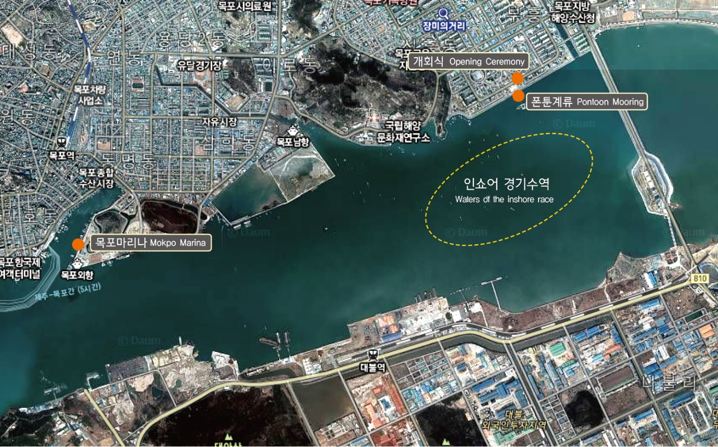

Annex 2 Waters of Mokpo-Cheongsando Island for the parade, waters of Cheongsando Island inshore and offshore race
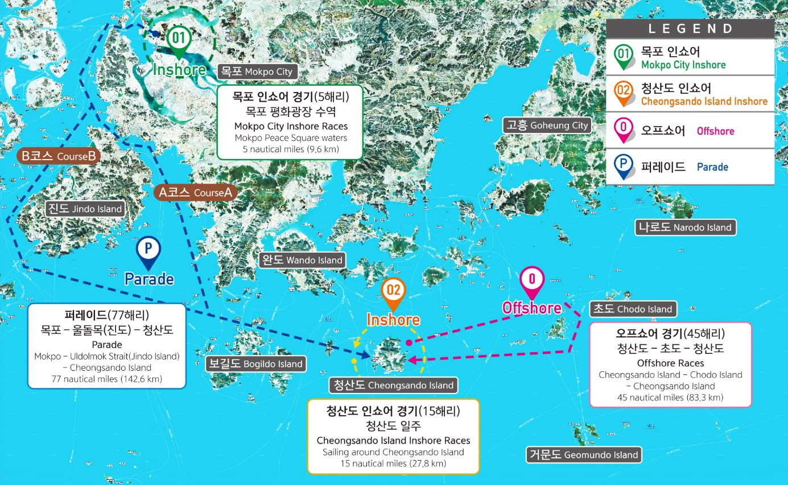

Annex 3 Waters of Cheongsando Island mooring

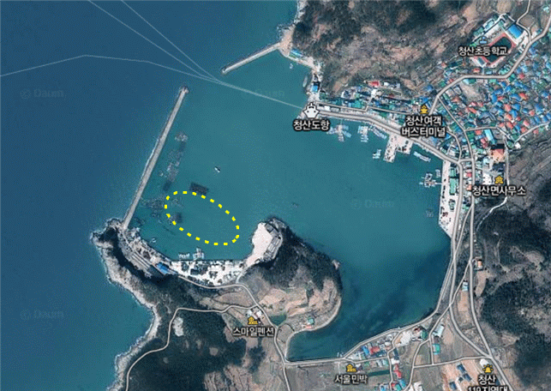
Annex 4 Application for Participation

The 4th "Dadohae Cup" International Regatta 2016
Application for Participation
Yacht Specification
Yacht Name |  |  |  |  | Manufacturer |  |  |  |  | Model Name |  |  | Sail No.
Port of Departure |  |  |  |  | Full length |  | ft |  |  | Full width | ft |  | Weight |  |  | ton
Skipper
Name |  |  | I/D Number |  |  |  |  | Address |  |  |  |  |  | Mobile Phone
Crew
No. | Name |  |  | Date of Birth |  |  |  |  | Address |  |  |  |  | Mobile Phone
1
2
3
4
5
6
7
8
9
10
Bank Account Details
Bank |  |  |  |  |  | Account Number |  |  |  |  |  | Account Name
I represent the crew members participating in this race and hereby pledge to follow the ISAF Race Rules, IRC Class Rules, Special Rules of the Race Committee, Special Race Rating Rules and the Sailing Instructions.
2016. Month Day

Skipper Signature

Annex 5 Written Pledge

The 4th "Dadohae Cup"
International Regatta 2016

Written Pledge

Name: Date of Birth:
Address:

I (Skipper or Team Leader) pledge that in the case of criminal or civil suit accidents occurring while participating in the 4th “Dadohae Cup” International Regatta 2016 that were caused by the carelessness of myself or the crew members, or due to poor management, I will not ask Sehan University Industry-Academy Cooperation Group and the Organizing Committee to take any responsibility, and will not file any criminal or civil suits.

2016 Month Day

Name (Signature or Seal)

To Sehan University Industry-Academy Cooperation Group

